Hopedale Community News

Volume 33, Number 10 May 2022

Sunday Services via Zoom – Service 10:30 a.m.; Open 10:20 a.m.

April Sunday Services
Multi-platform (Both In-person and via Zoom)
Please see reservation information in “Around Hopedale”
Zoom Invitation Sent by Email from huucoffice@gmail.com

May 1st – “The Power of the Pause: Using Mindfulness to Navigate Life Decisions” with Terri Messman. Mindfulness strengthens our ability to be in the “here and now,” but is that all? Actually, it is just the beginning. Our capacity to focus our attention, and to notice our thoughts in a nonjudgmental and curious manner, allows us to respond rather than react. Mindfulness creates the space for us to pause and reflect to make intentional decisions rather than react impulsively to present circumstances. Mindfulness also contextualizes the present moment within the past and the future so that we can examine where we’ve been and where we want to go. Nonreactivity, or the ability to pause in the present moment, clarifies our goals and values, thus improving decisions. Increased awareness of discomfort or pain related to the dissonance among our thoughts, feelings, and values can motivate our desire for change. Mindfulness increases our awareness of our discomfort, signaling that a decision should or could be made so to enhance the congruence between our decisions and our fundamental values. Service leader: Ann Elizabeth Armstrong. RE: Activities.

May 8th – “My Mom Always Helps Me and She Taught Me Not to Play with Sharp Knives” On Mothers’ Day, come join Patty Klingenberg and Diane Wright for an intergenerational service where we will explore what it means to have a mom, to be a mom, or to be a friend of a mom. Service leader: Patty Klingenberg.

May 15th – “The Time for the 8th Principle is Now.” Join Libby Earle in an examination of the reasons for supporting an 8th Principle: We, the member congregations of the Unitarian Universalist Association, covenant to affirm and promote: Journeying toward spiritual wholeness by working to build a diverse multicultural Beloved Community by our actions that accountably dismantle racism and other oppressions in ourselves and our institutions.

Every fifteen years Unitarian Universalists review our Bylaws which state the reason for our existence and our core principles, their sources, and our values. The Unitarian Universalist Association (UUA) has been engaged in this process since 2006. This examination has been difficult, beginning with an independent commission’s proposed changes not being sent to the 2010 General Assembly (GA), and coming to a head with the resignation of the UUA President and two other top UUA Board members following accusations of racial discrimination in hiring practices. In 2017 the Commission on Institutional Change was formed. The Commission’s thorough and sensitive work of auditing the power structures and analyzing systemic racism and white supremacy culture with the UUA resulted in their 2020 report: “Widening the Circle of Concern.” The report clearly identified racism, which is systemically embedded in a national culture of white supremacy, as something that is all too easy for white people to ignore, thus keeping racism alive and well. The 8th Principle calls us to center this issue in order to build Beloved Community. Some form of it will be presented to the 2022 GA in June. Service Leader: Jennifer Blue. RE: Activities and preparation for May 22nd service.

May 22nd – “Hopedale Children’s Religious Education and Bridging to Adulthood.” This multi-generational worship service will include a Bridging Ritual for our newest Young Adult, Kiefer Bell. There will be time to recognized him and his family as he makes this important transition from youth to young adult. We will also have reflections on Hopedale’s community of children, how we’ve fared through the Pandemic and what we envision next. Service Leader: Genevieve O’Malley Knight, Religious Ed Co-oordinator.

May 29th – “Flower Communion” with Patty Klingenberg. We will celebrate this unique UU ritual as an intergenerational service where children will actively participate. Designed during the lead-up to World War II, the flower communion is an expression of worth of human life in all its diversity. Stay tuned for ways that those at home can experience the joy. Presenter and Service Leader: Patty Klingenberg.

Notes From Board President Curt Ellison
ellisocw@miamioh.edu 513-461-1131

Spring Congregational Meeting

Our biennial Congregational Meeting was held in multi-platform format Sunday afternoon, April 24. The resilience and notable achievements of our Community during a pandemic for the past two years were applauded. Hopedale has been solid during a challenging time and innovated creatively to address new circumstances. We believe we are prepared to thrive in an endemic future.

Thanks to Canvass Chairs Peter Carels and Celia Ellison, and to Congregation members who stepped up to support Hopedale, our pledge drive was successful and the operating budget for fiscal 2022-23, as presented by Finance Committee Chair Liz Woedl, was adopted. On behalf of committee members Jane Flueckiger and the late Susan Thrasher, Nominating Committee Chair Linda Amspaugh presented a slate of officers for 2022-24. Curt Ellison as President, Celia Ellison as VP for Congregational life, and Drew Reuther as VP for Stewardship were unanimously elected. The two-year terms of Judy and Richard Schlub as a Treasurers, Darrel Davis as VP for Religious Services, and Neil Danielson as Secretary will continue during 2022-23.

Task force Leads Neil Danielson for In-Person Gatherings and Robert Bell for Facilities Improvements reported on their work, positive outcomes, and ongoing plans. Treasurers Judy and Richard Schlub reported that our current year operating budget is in good order, the Facilities Fund has paid the renovation costs of the lower level and has a positive balance. Vice Presidents Darrel Davis for Religious Services, Celia Ellison for Congregational Life, and Drew Ruther for Stewardship reviewed achievements in their areas, efforts now under way, and future plans.

Comments by members of the congregation during the meeting included a sincere thank-you to the Congregation from RE Coordinator Genevieve O’Malley Knight for rehabilitation of the lower level, praise for the creative ways that Hospitality and Religious Education reached out to members in their homes during the pandemic, and gratitude that Hopedale has consistently followed scientific understanding and public health guides for our gathering behavior during the pandemic. A video recording of this meeting is available if you wish to see it. Contact me.

Multi-Platform Gatherings

We began regular multi-platform Sunday services on February 27. As risk levels continue to improve, larger numbers of people can be in the building. A sign-up procedure is in place for vaccinated adults and for children to attend Sunday services in person. Those who wish to attend a multi-platform gathering should contact VP for Congregational Life Celia Ellison each week. Anyone who cannot be present is welcome to join us via Zoom to take part in any multi-platform event. In addition to the April 24 Congregational Meeting, a multi-platform open house and rededication of the lower level for Religious Education was held on April 10 with Diane Wright, and a special musical concert was presented for Hopedale by pianist Evan Danielson on April 17.

Generous volunteers are coordinating, setting up, and operating the technology needed to manage different types of multi-platform gatherings – Zoom hosts include Neil Danielson, Celia Ellison, Curt Ellison, Pat O’Malley and Darrel Davis. The Sunday Services Committee is now providing a volunteer Coordinator to support multi-platform gatherings, and Celia Ellison is serving for the remainder of this year. The Social Justice Committee is currently making plans to offer multi-platform gatherings this summer.

Lower-level Rehabilitation

Planned physical improvements in the lower level are complete. Insulation and wallboard have been installed on all exterior walls, and on all walls in the nursery. New closet storage has been built in the main room. LED lighting has been installed; the bathroom has new flooring; the nursery has a new drop ceiling; all vinyl flooring has been cleaned; and everything, including the stairwell, is newly painted. Moveable interior dividers are being shopped by an RE committee, and acoustic treatments will be added in some areas if needed.

The Chalice Lighter Grant and Hopedale Facilities Fund have covered rehabilitation costs. Hopedale donors to the Facilities Fund made this project possible, and we can be grateful to them for our improved Religious Education facilities. Move-in was done by Drew Ruther and a team of volunteers, and in-person RE is once again under way!

Facilities Improvement Priorities

Our property has what some characterize as chronic drainage issues, and during recent construction work, when we were in the building daily, we saw evidence of this. We are now actively reviewing recommendations and cost estimates for work necessary to address moisture entering the building at the base of the foundation during certain weather conditions. We also discussing gutter drains and drainage of lawn areas. These basic maintenance concerns affect our outdoor space, driveways, parking areas, and the building’s lower level. It will be desirable to address them effectively if possible.

After this maintenance work is done we can install hard-surface accessible parking spaces and rehabilitate driveways and parking areas. Next will come the possibility of installing a lift, upgrading upper-level restrooms, and perhaps creating separate spaces for worship and social activities. The Construction Task Force, the Finance Committee, and the Board will be deliberating these matters and moving forward as planning and financing permit. Contributions to the Facilities Improvement Fund or to maintenance agendas are most welcome. Major improvements will likely require mortgage refinancing within guidelines set by the Congregation last year. Any specific plans for future worship space expansion will reviewed with the Congregation before they are pursued.

Upcoming UUA Gatherings

The UUA MidAmerica Regional Assembly 2022 will be held online Saturday, April 30. Genevieve O’Malley Knight will attend as our Religious Educator and credentialed voting delegate. This year’s UUA General Assembly will convene as a multi-platform event originating in Portland, Oregon from June 22 to 26. Liz Woedl and Libby Earle will be Hopedale’s credentialed voting delegates, and Genevieve O’Malley Knight will attend as Religious Educator.

Next Board Meeting

The Board will meet via Zoom on May 10 at 7:00 p.m. Let me know if you would like to receive the Zoom invitation.

Stewardship
By Drew Ruther, VP
513-265-1538 andrew.ruther@gmail.com

Greetings Hopedale Members & Friends,

The outdoor areas of Hopedale have awakened and are eager to be tended. We did a great job of maintaining and improving our various gardens and outdoor areas last year and my hope this year is that we continue to be deliberate and resourceful in our work. In addition to our regular gardening and mowing duties, there will be some large projects like adding a few concrete parking spaces and spreading gravel on our parking lot that will take place at some point this summer.

We are always looking for help during our work sessions and there are jobs for any and all skill levels. We’ll hold two work sessions in May, the first on Saturday, May 7th from 1:00 p.m. to 3:00 p.m., and the second on Saturday, May 28th from 10:00 a.m. to 12:00 p.m.

Salad veggies are growing well in the mini-greenhouse and, along with the rhubarb, will be ready to pick before long. But the primary gardeners, Peggy Branstrator and Mary Fox, NEED HELP weeding the flower beds. This job did not get completed last fall. Our goal is to keep the grass and weeds from spreading into the beds so that we do not have to mow the beds to significantly reduce their size for easier maintenance.

Consider this a personal invitation to stop by any time – especially in the next few weeks while the weeds are small – and pull a few weeds!! You don’t have to await a scheduled workday. Call or text Peggy or Mary with questions if you want – their cell numbers are in the directory. They may even be there working when you arrive!!

As always, contact Drew Ruther (andrew.ruther@gmail.com or 513-265-1558) with questions or comments.

Religious Education CONNECTION
Genevieve O’Malley Knight, RE Coordinator 513-593-3275
Genevieveaok (at) yahoo (dot) com
RE Committee: Jennifer Blue, Valerie Elliott, Adriane Ruther; Darrel Davis (VP, Religious Services)

Downstairs is Beautiful!

A huge thank you to everyone who helped with moving back into the Lower Level!! It’s beautiful, clean, insulated, everything works, and the space is ready for us!

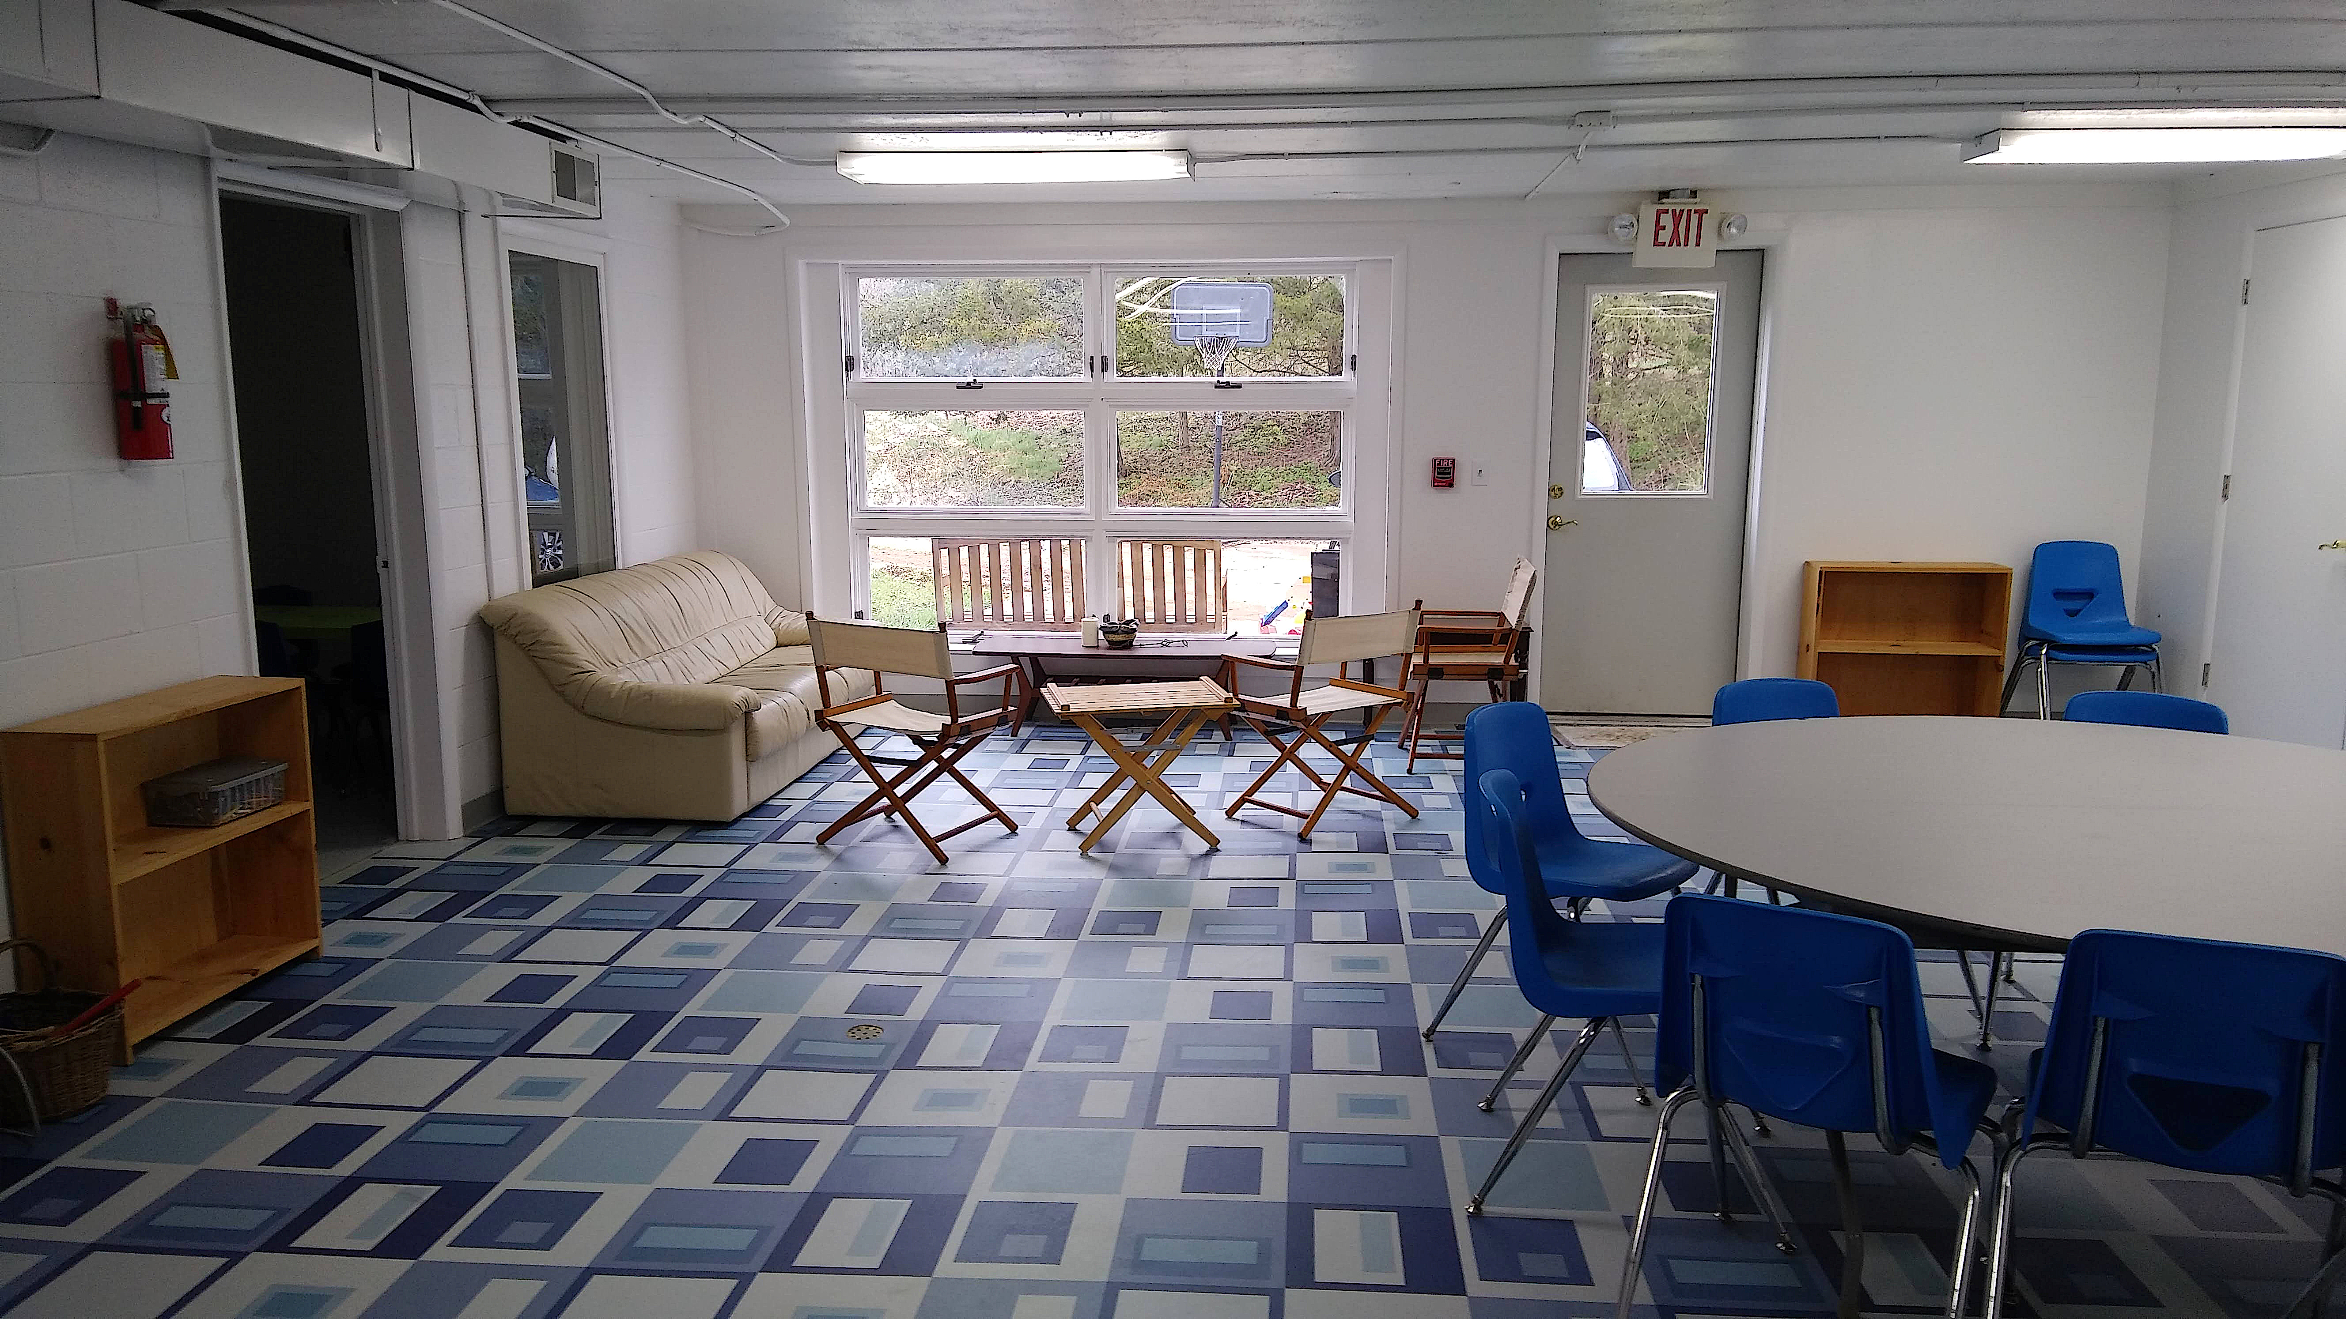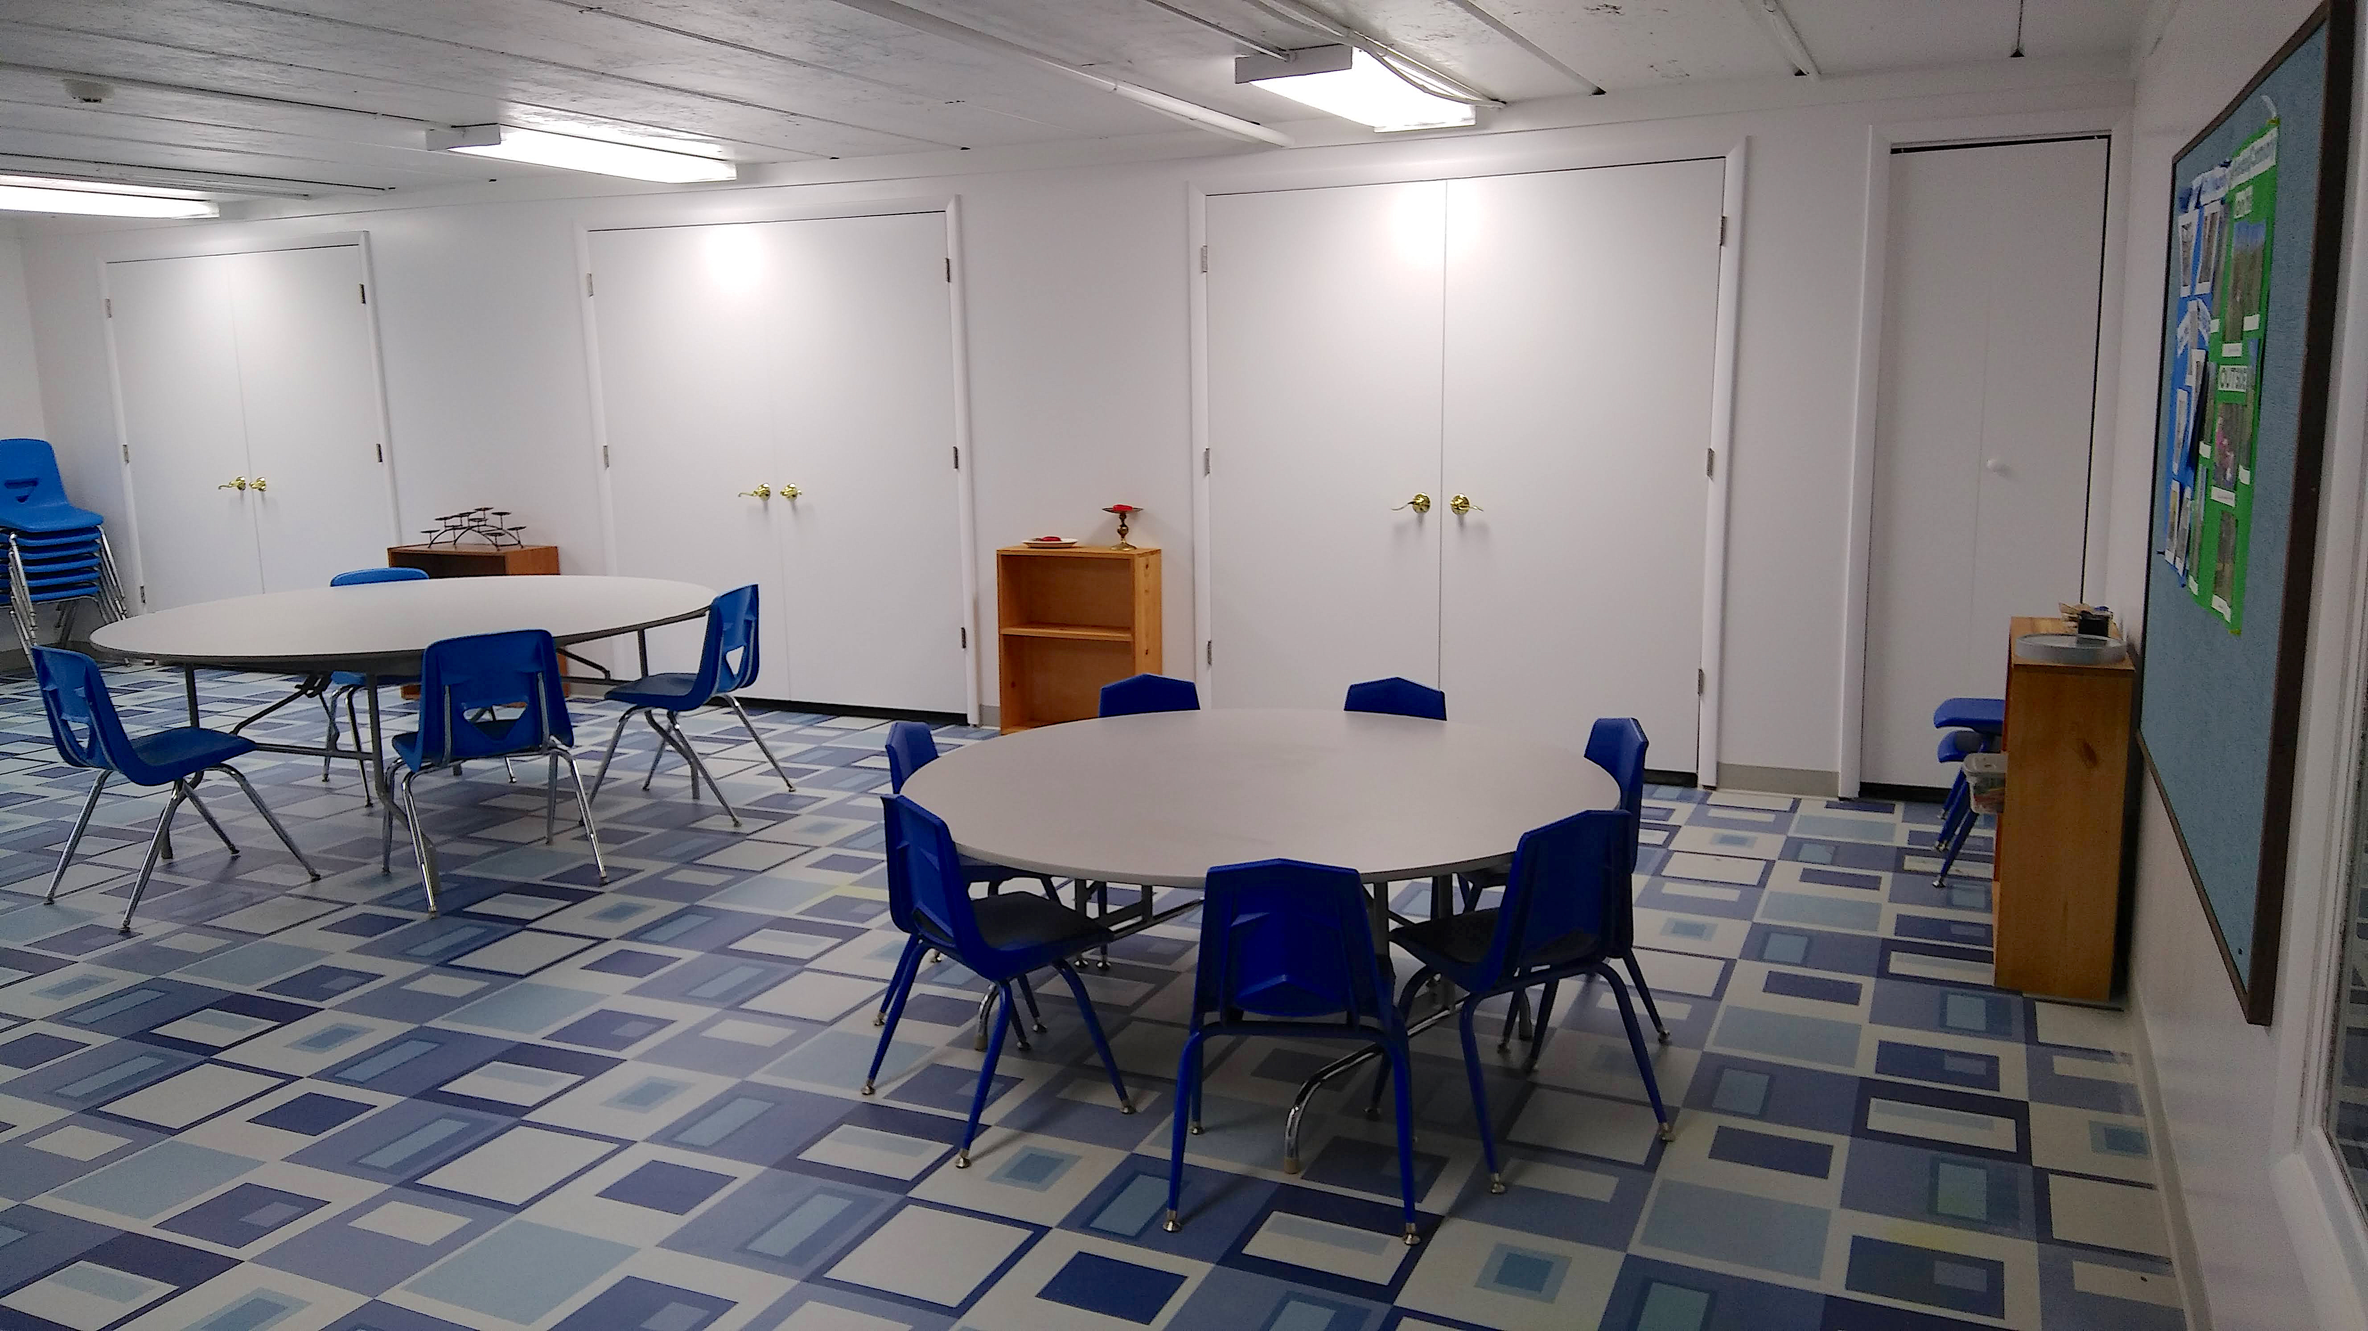

I hope each of you can visit the space soon and enjoy it.
Our Whole Lives – 7th to 9th Graders Come to Hopedale

This coming fall (’22-’23), Hopedale will offer the Owl Whole Lives (OWL) faith-based sexuality education curriculum to our 7th, 8th, and 9th graders. For many (pre-pandemic) years our Community has been part of a Cincinnati-based consortium of congregations that offered this course every other year, and we’re very excited to be able to offer it as a Hopedale program this coming year. Invitations have gone out to the families of our kids in this age range. If space permits, we’ll extend invitations to other area Unitarian Universalist kids.

A huge thank you to Jennifer Blue, who has been Hopedale’s lead OWL person for years, and a huge thank you to Darrel Davis, who is being trained as an OWL facilitator this spring! I think this program is one of the flagship things the UUA does, and I’m so grateful that it’s part of Hopedale’s offerings this coming year.

May Schedule
May 1 – May Day Activities
May 8 – Mothers’ Day Multi-generational Service
May 15 – Activities and Preparation for May 22nd Service
May 22 – Children’s Religious Education Sunday and Young Adult Recognition
May 29 – Flower Communion Multi-generational Service

Notes from the Social Justice Committee
Liz Woedl, Libby Earle, Mary Fox, Peggy Branstrator, Bethany Smith, Russ VieBrooks

This summer, as part of renewing Hopedale's ongoing commitment to being a Welcoming Congregation, the Social Justice Committee will host and coordinate “Transgender Inclusion in Congregations." The six-session course from the Transforming Hearts Collective will be facilitated by Ann Fuehrer and Libby Earle. Hopedale's members and friends are encouraged to attend. Mark your calendar for these dates: July 10, 17, 24, 31, Saturday Aug 6, and Sunday Aug 7. We'll give you more details later.

At the May 15 Sunday Service, Libby Earle will talk with Hopedale about the proposed addition of an 8th Principle to our denomination's 7 Principles. At that service, we will pass the rainbow basket to collect donations to be sent to an organization, suggested by the Unitarian Universalist Service Committee (UUSC), to help send humanitarian aid and comfort to the people in Ukraine. If you will be paying by check, please make it out to Hopedale UU Community and write UKR in the memo line. If you won't be at the service, send your check to our treasurer Richard Schlub, 2849 Stone Mill Way, Hamilton, OH 45011.

The Committee has about 200 of the League of Women Voters Government Directories. The directories are a great offline source for contact information for elected officials and local commissions and government offices. There will be copies available at Hopedale and we can make sure you get one if you request a copy.

The Committee has identified two issues for long-term education and involvement: housing for homeless and low-income persons and voter registration and participation. There are many ways to help encourage others to vote through the League of Women Voters of Oxford, and UU the Vote. UU Justice Ohio may have some voting action options upcoming as well.

We welcome new participants! The Social Justice Committee, HUUC meets monthly on the 2nd Thursdays, 7:00 pm. Contact Liz Woedl, for the Zoom link if you’d like to attend, liz.woedl@gmail.com.

Coming up:
• Thu, May 12 – Social Justice Zoom meeting, 7:00 p.m.
• Sat, May 14 – UUCGC meeting, 9:30 a.m.
• Sun, May 15 – The 8th Principle – Service and collection for the people of Ukraine
• Thu, Jun 9 – Social Justice Zoom meeting, 7:00 p.m.
• Wed, Jun 22 – Sunday, June 26, 2022 – UUA General Assembly, Portland, Oregon
• Sat, Jun 25 – Cincinnati Pride Parade and Festival

Environmental Corner
By Peggy Branstrator
jonwb@earthlink.net

Solar Cookers International (SCI) was one of several organizations receiving the Keeling Prize for 2021 for their work in reducing greenhouse gas emissions by promoting solar cooking around the world, especially in refugee camps. Solar Cooking addresses all 17 of the United Nation Sustainable Development Goals, especially improving women’s and children’s health by reducing indoor air pollution. Some of you may remember SCI from a presentation I did a few years ago. If the name Keeling sounds familiar it’s because that scary curve of the recent rapid increase in Carbon Dioxide levels is called the “Keeling Curve.” The awards are given to organizations and projects that “bend that curve/”

The League of Conservation Voters Scorecard < https://scorecard.lcv.org/> is available for voters interested in finding out how legislators voted on national legislation about environmental issues.

For Ohio environmental issues you can find information at the Ohio Environmental Council link The OEC Action Fund. They recently released their scorecard for Ohio’s 134th General Assembly detailing how Ohio lawmakers voted on key state environmental issues in 2021 and reviewing Gov. DeWine in the third year of his term. The scorecard is created to hold Ohio lawmakers accountable for votes that damage our environment, as well as to celebrate those lawmakers who have championed pro-environmental legislation. Check out the scorecard here . The website for this 3-page document is http://theoecactionfund.org/134ga.

There is also information about the role of OEC in the Ohio Redistricting process on their website. For the latest on Ohio redistricting see the Fair Districts Ohio webpage. And there is always the OpenSecrets webpage to track where politicians are getting money.

Voting
There are three times to vote this year because OHIO WILL BE HOLDING TWO PRIMARIES IN ADDITION TO THE NOVEMBER GENERAL ELECTION. The May 3 primary will be for some local issues like Butler County Auditor, Ohio governor and Ohio candidates for US Senate and House seats. The maps being used for US House Districts (May 3) are similar to the ones the Ohio Supreme Court ruled unconstitutional and are being challenged again. That challenge has been modified to apply to the 2024 elections not the 2022 elections.

The maps being used for the Ohio General Assembly primary in August are still being litigated. As I write this, the 4th set of GA maps were declared unconstitutional by the Ohio Supreme Court and the redistricting commission was ordered to try again using the maps from the independent mapmakers as a starting point. But the commission has not met and appears to have no plans to do that. That is because the Federal District Court has announced that if the commission has not reached agreement by the end of May they will impose the third map – which is seriously gerrymandered. This is exactly what the majority of the commission wants to happen. You can sign a letter protesting this antidemocratic outcome at <bit.ly/OHFairMaps>.

Congregational Life
By Celia Ellison, VP
513-461-1204, knightcm@miamioh.edu

In Remembrance

Susan Thrasher, beloved mother, grandmother, sister, and friend, passed away on April 2, 2022 at her home in Oxford, Ohio.
Born in Ann Arbor, Michigan, Susan was a champion swimmer and a pioneer of women's athletics at the University of Michigan. In 1961 she was named an AAU All-American in the 100 and 200-yard butterfly and the long-distance and water polo teams. She was among the members of the first Univ of Michigan women's swim team and was inducted into the Univ of Michigan athletics Hall of Fame in 2007. When not in the pool, Susan earned a BS in Dental Hygiene from Columbia University (1971), a Master of Public Health from the Univ of Michigan (1976), and an MS in Library and Information Sciences from the University of Illinois (1990). She was a cherished children's librarian at the Lane Public Library in Oxford, Ohio, from 2001 to 2009. She had a specific talent and love for helping kids discover the joy of books and their own passion for reading and storytelling.
From Ann Arbor to Champaign-Urbana to Oxford, Susan loved college towns and took advantage of every experience available. During her time in Oxford, Susan was an active member of the Oxford Senior Center and the Hopedale Unitarian Universalist Community. She continued to swim nearly every day at the Miami University recreation center pool.
Beyond her accomplishments in and out of the pool, Susan was most proud of her four grandchildren and her two sons – Peter of Salt Lake City, Utah, and Brynn of Charlotte, North Carolina. There was nothing she loved more than seeing her two boys. Susan was preceded in death by her parents, Clyde and Betty Thrasher of Ann Arbor.
Susan had a wonderful sense of humor, loved good food, good music, and a good chat. She found joy every day and her laugh and her stories will be remembered by all. She will be deeply missed by her sons Peter (Marnie) Saunders and Brynn (Kelly) Saunders; grandchildren Zoë Saunders, Zade Saunders, Grace Saunders and Sam Saunders; brother Steve Thrasher and wife Jena; nephews Gus (Selena) Thrasher and Tyler (Wendy) Thrasher; her "Sassy Seven" and many dear friends.
Donations may be made in Susan's name to the Oxford Senior Center www.oxfordsenior.org or Hospice of Cincinnati www.hospiceofcincinnati.org/memorials.
Around Hopedale
By Celia Ellison, VP, Congregational Life
knightcm@miamioh.edu;513-461-1131

Accomplishments

Evan Danielson was the recipient of a Goldwater Scholarship, the premier national undergraduate award for students intending a research career in mathematics, natural sciences, and engineering. The Goldwater Scholarship Program encourages, identifies, and supports students who show exceptional promise of becoming the next generation of research leaders. While we see the music performance part of Evan’s double major, his other major is chemical engineering. His faculty mentors are Jason Berberich and Jason Boock. Evan also performed his Miami Senior Recital at the end of April, and graciously performed his pieces for our Hopedale Community on April 17th.

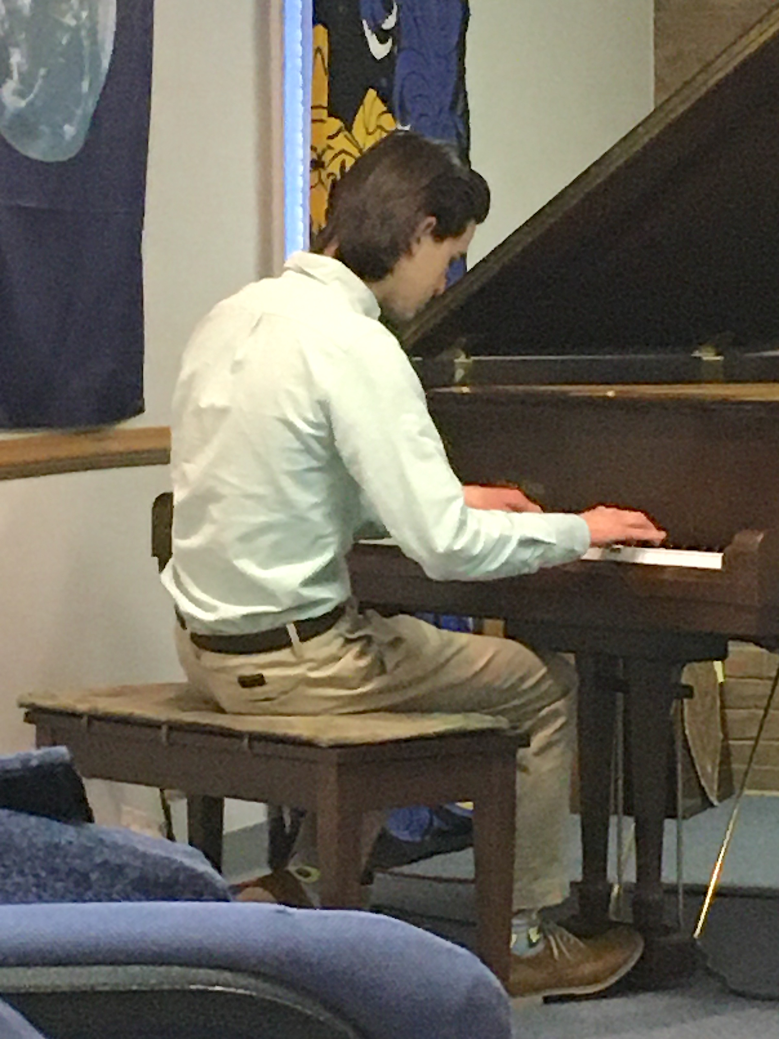

A CHALLENGE!

At the Spring Congregational meeting, VP of Religious Services Darrel Davis challenged all of us to grow our congregation. Think about what our community has to offer and invite someone you know to visit us – and do so this month!!!

Making Multi-platform Work on Sunday Mornings!

Our multi-platform (both in-person and via Zoom) services continue!

RE was successfully reconvened in April and continues in May.

We will also continue to follow our established Hopedale guidelines, based on CovidActNow risk indicators, regarding the building’s capacity and mask wearing. Currently we are in a low risk category which appears to have a flat trend. Based on our guidelines, inside attendance is now only limited to building capacity. We do still advise social distancing and mask wearing when in close proximity. We hope to start food and beverages again soon. RSVPs are not currently required for those who plan to attend in person. The congregation will be notified of any change in the risk category that would indicate a limited service attendance.

Beyond Hopedale

• Sat, May 14 - UUCGC meeting, 9:30 am
• Wed, Jun 22 - Sunday, June 26, 2022 - General Assembly, Portland, Oregon
• Sat, Jun 25 - Cincinnati Pride Parade and Festival

Happenings at Hopedale

May 7 – Outdoor Workday 1:00 – 3:00 p.m.
May 10 – Hopedale Board meets via Zoom at 7:00 p.m. If you wish to join this meeting, email ellisocw@miamioh.edu or call 513-461-1131 for the Zoom invitation.
May 11 – Wednesday Wine (or something else), 5:00 p.m. or so at Cru in Oxford.
May 12 – Social Justice Committee Zoom Meeting, 7:00 – 8:30 p.m. Contact Liz Woedl at liz.woedl@gmail.com if you would like the link to attend.
May 28 – Outdoor Workday 10:00 a.m. – noon

Weeding the flower beds available anytime!!
References from April Services

April 3rd – “Sharing Poetry” with Doris Bergen and Patty Klingenberg
Some of the poems shared by:
Celia Ellison: “End of Winter” by Eve Merriam
Genevieve O’Malley Knight: “Casey at the Bat” by Ernest Lawrence Thayer
Libby Earle: “The Time of Dirty Snow” by Libby Earle
Doris Bergen: Excerpt from “Ulysses” by A. Tennyson
Lilly O’Malley: “Alarm Clock” by Eve Merriam
Resources:
Poems shared by Patty Klingenberg from Secrets and Stars by Alix Klingenberg, available from independent bookseller at contact@poetsgardenalchemist.com as well as from Amazon.

April 16th ⁻⁻ “Perfect Strangers” with Muriel Blaisdell and Cynthia Kelley.
Resources/References:
Archaeology Study Bible, New International Version.
Harper’s Bible Commentary

April 24th -- “The Interdependence of Life,” Our 7th Principle, with Adriane Ruther and Sara Morris.
Story for All Ages: The Great Kapok Tree: A Tale of the Amazon Rain Forest by Lynne Cherry.

Support Hopedale

Pledge Payments or Hopedale Facilities Fund Donations can be made to either “Hopedale UU Community” or “Hopedale Facilities Fund” and sent by U.S. Mail to Treasurers Richard and Judy Schlub, 2849 Stone Mill Way, Hamilton, OH 45011.

Contributions to the Hopedale Facilities Fund are devoted entirely to Hopedale physical facilities improvements. These may be mailed to the Treasurers along with the donor commitment form distributed earlier. If you need the form or have questions about either facilities improvement plans or ways to contribute to the Fund, contact the Treasurers at 513-895-0272 or Curt Ellison at 513-461-1131.
Members and friends have been generous and that is much appreciated, for it has allowed us to begin improving our building and grounds. Please remember that if we are to meet the Congregation’s prioritized facilities goals, we need your donor support.
All contributions to Hopedale are tax deductible.

